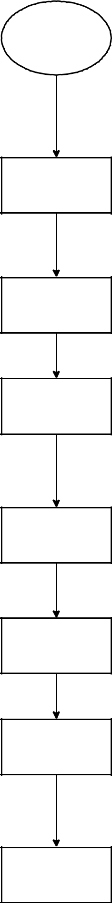
Botkit set up

Localhost set up

Acquire hosting for

webapp

Setting up facebook

creating a messenger

webhook

Connecting F.B to

web app

Create response for

chat bot

starge 1 complete

stage 2:Complete

stage 3: Pending

Stage 4 :Ongoing

stage 5: Incomplete

stage: 6 incomplete

stage 7:Complete

Publish chat bot to
stage 8:Incomplete
messenger.

Text

